Requirement Gathering Techniques
Two requirement gathering techniques were used, interviews and questionnaires, to understand the problems in the current ordering process and to identify the requirements for the proposed Restaurant Ordering System. The use of these techniques enabled information to be gathered from various parties involved such as the restaurant manager, cashier, and customers who are frequent visitors to Burger Hub.
Interviews
Interviews were taken from different people like restaurant manager, cashier and a few customers. Each Interview lasted for like 5-10 minutes and the question focused on the current situation in the restaurant, identifying common problems and some suggestions that would help improving the system. We have the record of whole interview of the manager of Burger hub.
Figure 1
General Interview Response Summary
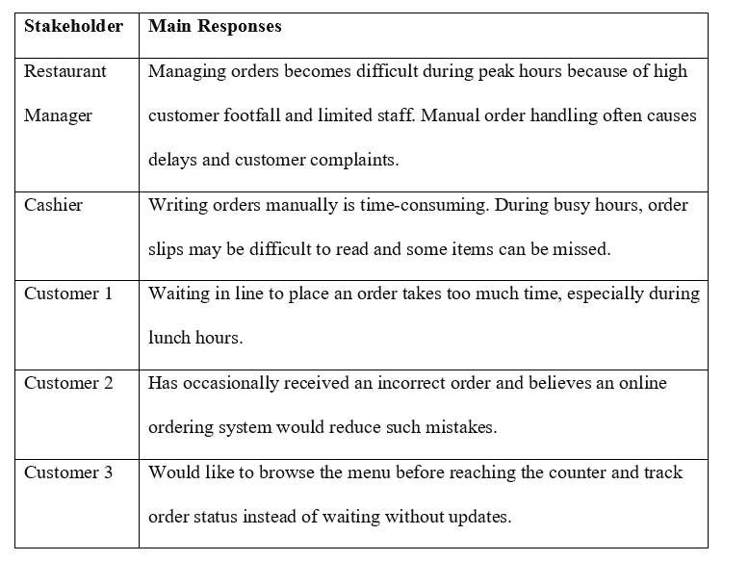
Figure 2
Interview session with the manager of Burger Hub
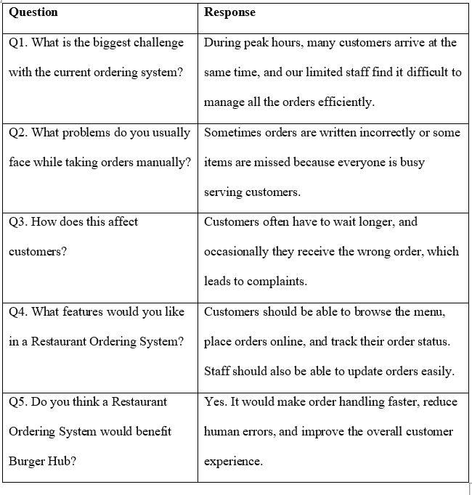
Questionnaire
The questionnaire was made using Google Forms and circulated to 25 regular Burger Hub customers to gather feedback from a broader audience of users. The questionnaire was targeted at their experiences with the existing ordering system and features they would like to see in the proposed ordering system.
The response indicated that the customers had a positive attitude towards the food quality, whereas the ordering process during peak hours was not as well-received. A significant number of respondents complained of long wait times and felt that an online ordering system would help to speed and simplify the ordering process. The customers also wanted features like browsing the menu, tracking an order, and getting a notification once the order was ready.
